Dear ,

You are going to create your AWS Academy Account and you must do it step by step carefully!

您將要創建您的AWS Academy帳戶，並且您必須仔細地一步步完成！

**If you do anything wrong, we will need to submit the support request to AWS and you cannot work on the coming labs. On the other hand, you will loss 5 marks in your assignment section as this is your first assignment and you have to complete it before 20 May 2018 at home!**

**如果您做錯任何事情，我們將需要向AWS提交支持請求，並且您無法在即將到來的實驗室中工作。 另一方面，由於這是您的第一份作業，您將在作業部分減5分，並且您必須在2018年5月20日之前在家完成！**

# Getting Started with AWS Academy Cloud Computing Architecture Curriculum

The purpose of this document is to help AWS Academy students enroll in and access *AWS* *Academy Cloud Computing Architecture* curriculum. The instructions provided in this document will help you to:

1. Creating an account in the Amazon.com
2. Create an account in the AWS Training Portal
3. Enroll in the AWS Academy Cloud Computing Architecture curriculum
4. Access the AWS Academy Cloud Computing Architecture curriculum
5. Access Lecture and Lab Content

# Creating an account in the Amazon.com

1. Go to <http://amazon.com/>
2. Click on **Sign in**.  
    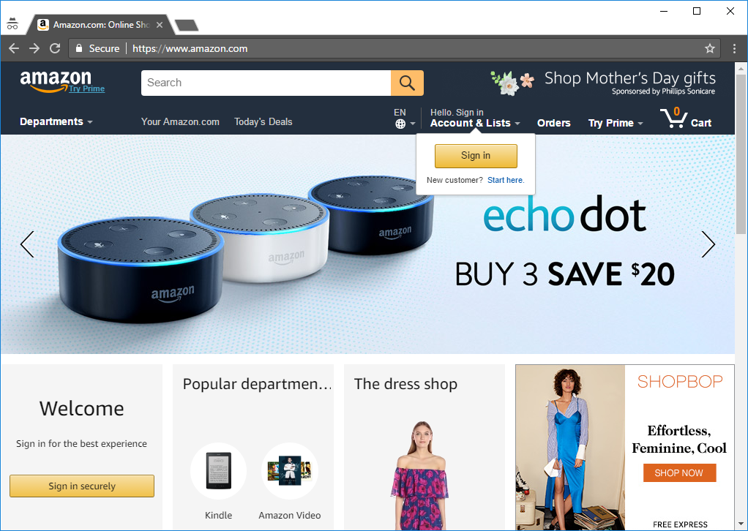
3. Click on **Create your Amazon account**.  
   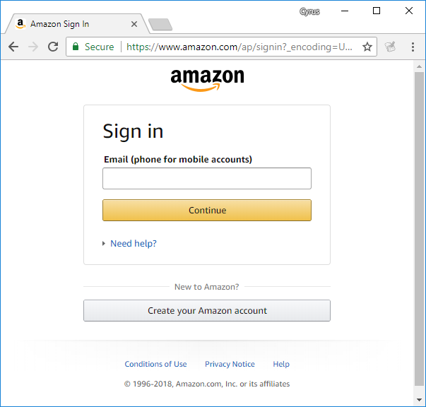
4. VERY IMPORTANT! You must follow the following name and email, else you will not receive any mark for all of your labs, online exercises and project!  
   **DON’T TYPE PLEASE COPY! If you are wrong, you lose 5 marks immediately!**

**(不要鍵入請複製！ 如果你錯了，立即失去5分！)**

Your name: **«Student_No»-«Class»-«NameCode» «Student_No»**

Email: **«Student_No»@stu.vtc.edu.hk**

(If you restudy this module, please use a personal email, and fill in this form!

如果您重新學習本單元，請使用個人電子郵件，並填寫此表格!

<https://goo.gl/forms/e5YHYkeyuEVuuddp2> ）

You can use any password, but you must remember it!

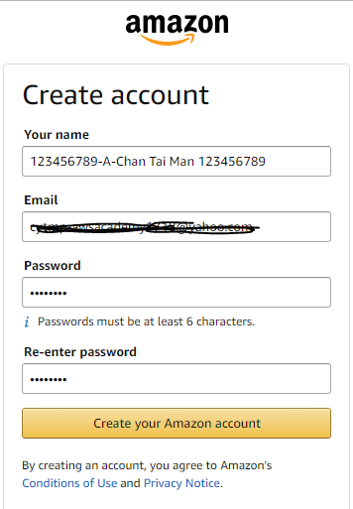

After you filled in the information, click on **Create your Amazon account**.

1. You will found your student ID «Student_No».  
   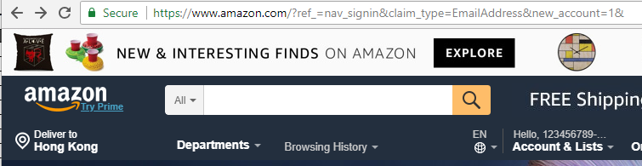
2. Don’t close this Tab!

# Creating an account in the AWS Training Portal

To create an account in the AWS Training Portal and enroll in AWS Academy Cloud Computing Architecture curriculum, you need a special registration link for each class.

1. Use the same browser and go to the link (使用同一個的瀏覽器!)  
   «Lab_Link»
2. Click on **Sign in with Amazon**. 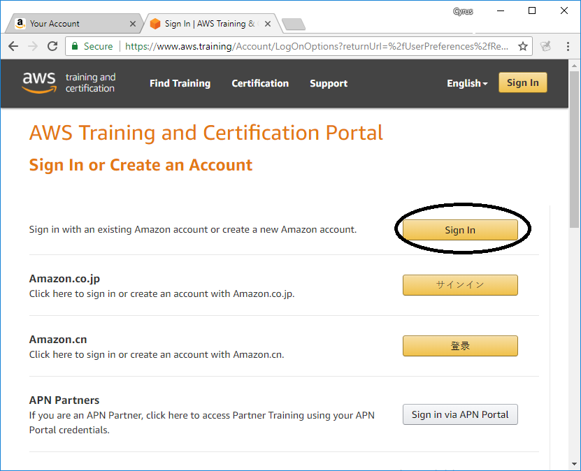
3. Enter your Amazon Account password, and click **Sign In**.  
   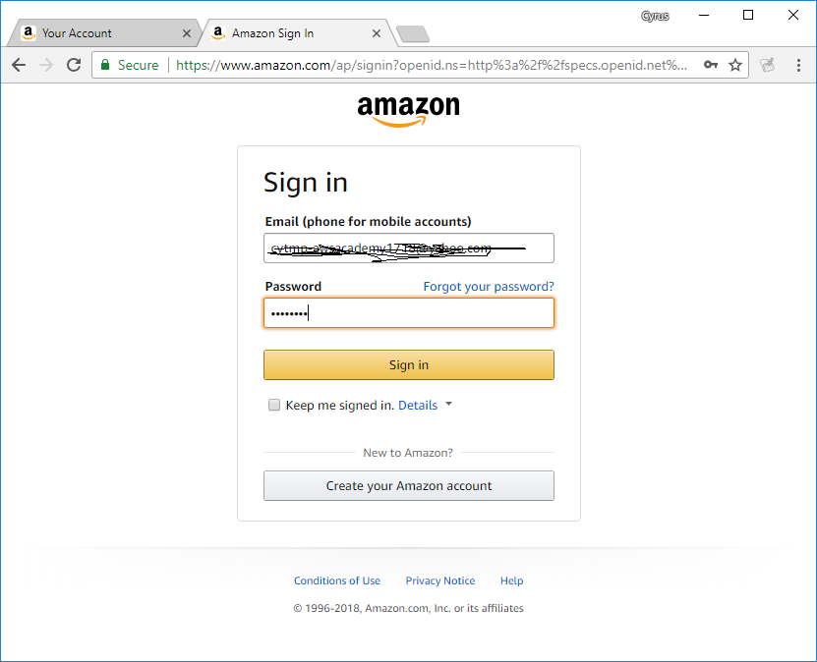
4. You will see the New Account Setup page.  
   Don’t let Autofill fill in the wrong email!  
   小心唔好填錯,唔好畀google autofill幫你填錯資料! 選擇Country千祈唔好打字!  
   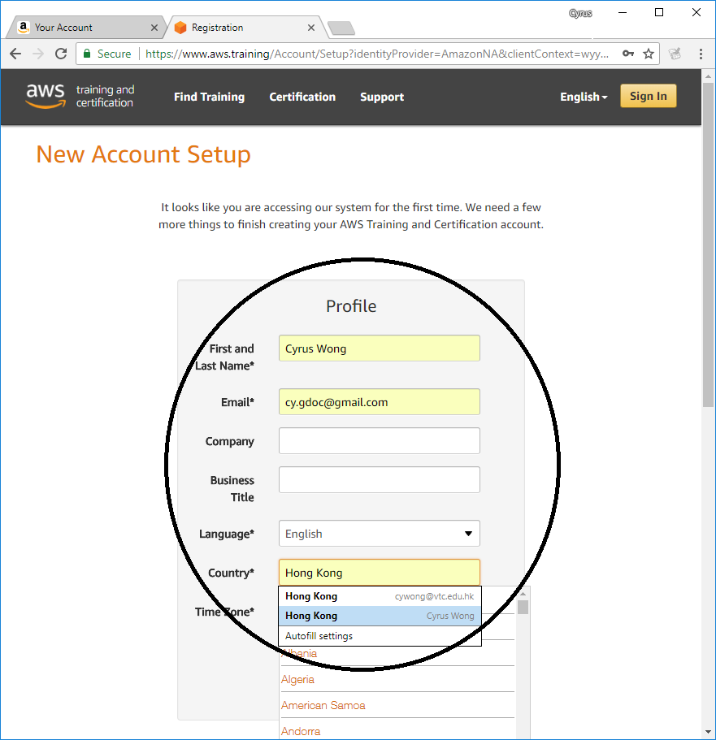  
   Input the following information:  
   Language: **English**  
   Country: **Hong Kong**  
   Time Zone: **China Standard Time (Asia/Hong_Kong, UTC +08:00)**  
   Check the **check box** before “By logging in, you agree to be bound by the AWS Training Terms and Conditions ….”  
   Click the **Save** button.  
   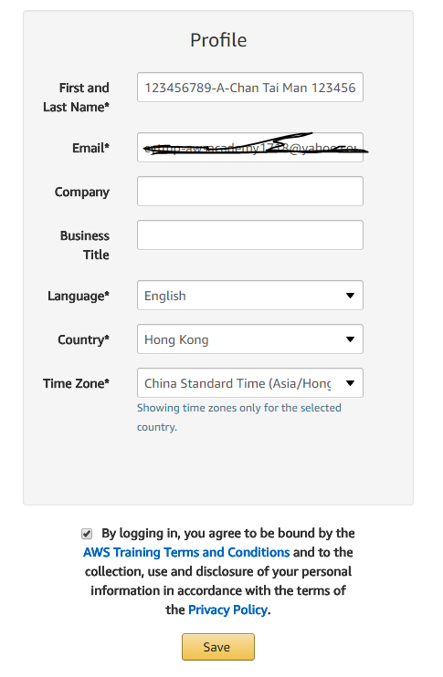
5. Click **Open**.

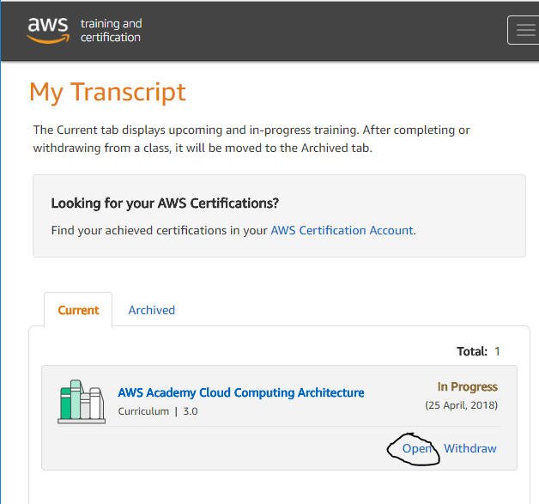

1. In the **Lecture and Lab Content** section, click **Launch Labs**. You will be redirected to Qwiklabs to access the labs and student guides.

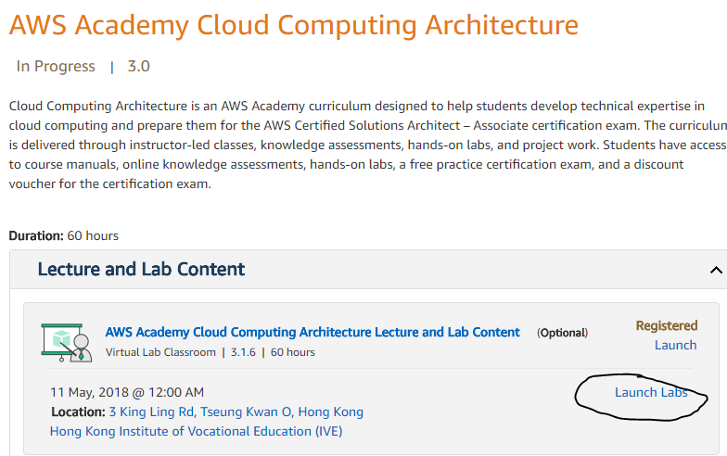

1. Click **Create new account in awsacademy.qwiklab.com**. to create your account in Qwiklabs

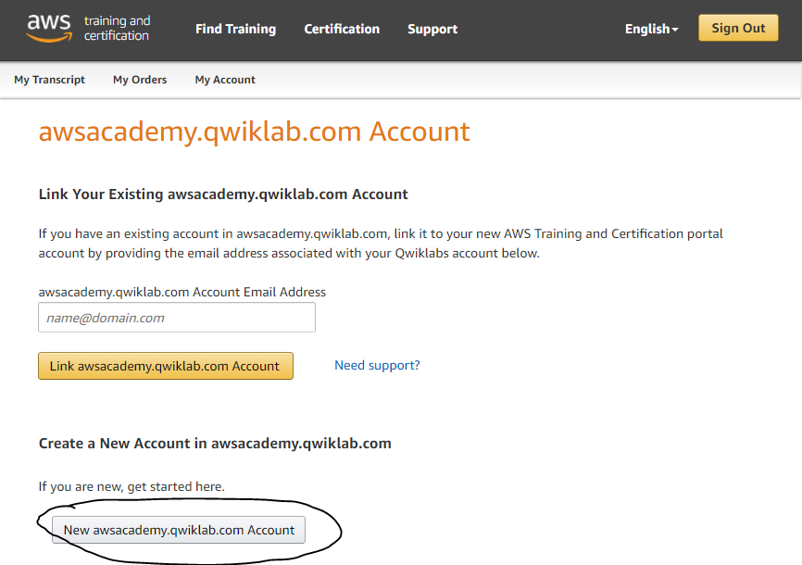

1. Click **Yes**.  
   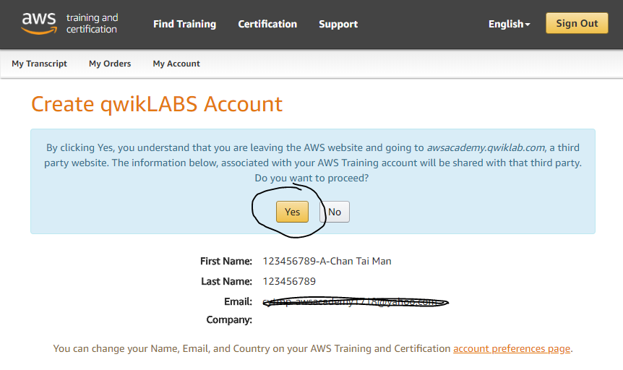
2. Click **Click here to continue**.  
   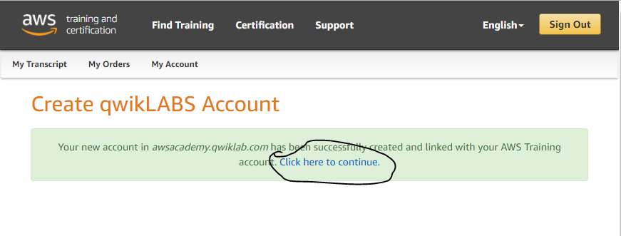  
   Wait for a few seconds.

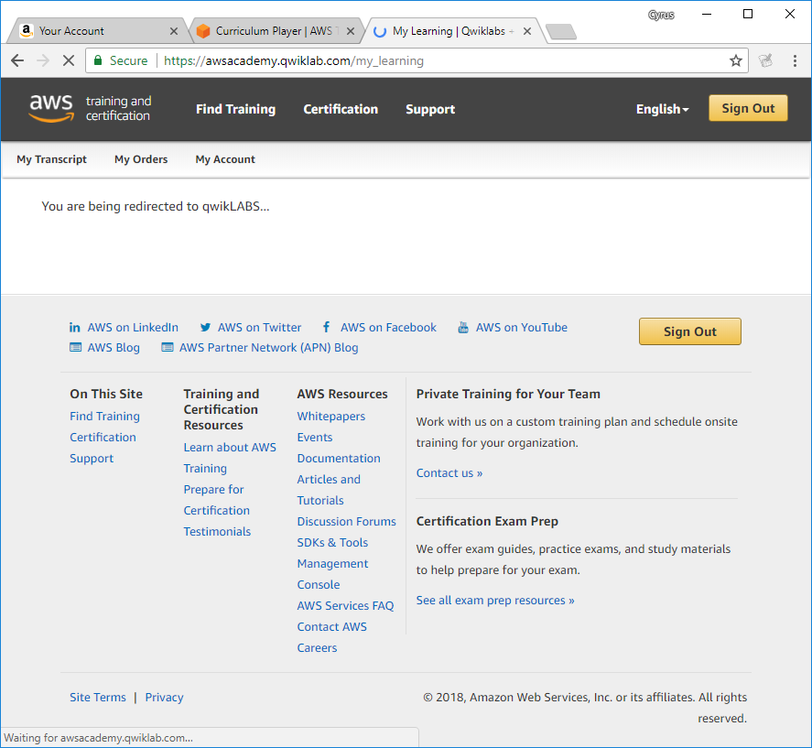

1. When logged in to Qwiklabs, click on the Cloud Computing Architecture class.

